Dear Scholarship Applicant:
Thank you for your interest in the Farmers Union Industries Foundation’s Stanley Moore Scholarship.
Please read the application materials, thoroughly. Not the scholarship is only available to Farmers Union members and their children in Minnesota, Montana, North Dakota, South Dakota, and Wisconsin.
If you have questions about the scholarship, please call me at 320-763-6561. We look forward to receiving your application.
Regards,
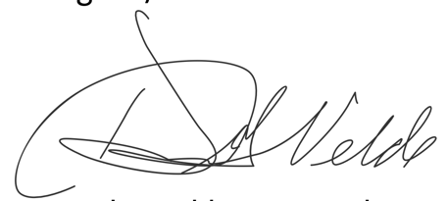
David G. Velde FUI Foundation

**Note**
If you are using Adobe Reader you will not be able to save changes to the form on your computer. If you are using a full version of Adobe Acrobat you should be able to use the Save As command to keep a completed copy of the form on your computer. When the form is complete please print two (2) copies - one for your records and one to mail to FUI Foundation, Attn: Bonnie Ahlbrecht, 220 Ponderosa Road, PO Box 319, Redwood Falls, MN 56283.
Please do not submit materials electronically.
Submit all materials at one time. However, if transcripts need to be sent directly from your school, make a note on your application.
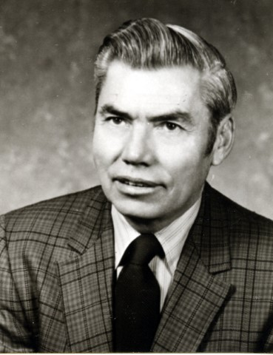
Stanley Moore was born into two prominent Farmers Union families, the Moores and the Talbotts. As a young boy, he traveled with his grandfather, C.C. Talbott, a principal organizer and the first president of the North Dakota Farmers Union.
After his education and military service in the Pacific during WWII, he immersed himself in Farmers Union and rose through the ranks for 30 years until he became president of North Dakota Farmers Union in 1975, a position he held until 1987.
In addition, Moore held many leadership positions throughout his lifetime, including serving as vice president of National Farmers Union from 1980-87; chairman of the National Farmers Union Insurance Companies (NFUIC) board from 1975-95; and NFUIC’s chief executive officer from 1987-89.
Moore was a man who provided great vision and leadership in both public policy and financial matters. He brought success to all facets of the organization because of his business savvy, people skills and his philosophy of service. He was known to say, “It doesn’t matter much who gets the credit as long as the job gets done.”
The long-term needs of the organization, in Moore’s estimation, required the laying of a base for future financial security for the organization. “If you don’t have the financial muscle, you can be the biggest advocate in the world for a particular program; but, if you can’t put wheels under it, you can’t make it work,” he said. To illustrate, one of Moore’s greatest contributions to the organization as chairman and president of Insurance Acquisition Corporation, another of his many distinguished leadership positions, was the reacquisition of the National Farmers Union Insurance Companies.
Moore was a strong advocate of education and his scholarship provides a lasting memorial in honor of his achievements and dedication to Farmers Union.
ELIGIBILITY: Open to Farmers Union members and their children in Minnesota, Montana, North Dakota, South Dakota, and Wisconsin. High school seniors, college students or non-traditional students seeking funding to attend a two- or four-year accredited college, university or technical school for any area of study.
AWARD CRITERIA: Academic record. Social and community activities. Written essay or oral presentation outlining your personal and professional goals and your involvement with Farmers Union. Please submit a 10-minute videotape or CD/ DVD for oral presentation. Priority given to ag-related study. Finalists may be required to participate in a phone interview.
AMOUNT: Several $1,500 scholarships will be awarded with money to be used for tuition and books.
APPLICATION MATERIALS TO BE RETURNED: Completed application form. Application MUST be typed. Copy of high school/college transcripts. Letters of recommendation from a Farmers Union leader and from a teacher or professor. Written essay (3 pages, 12-point Times New Roman font, 1-inch margin) OR 10-minute oral presentation. Please do not staple your application or essay.
APPLICATION DEADLINE: APRIL 26, 2024 RECIPIENT WILL BE SELECTED BY: JULY 31, 2024
RETURN MATERIALS TO: FUI Foundation
Attn: Bonnie Ahlbrecht
220 Ponderosa Road
PO Box 319
Redwood Falls, MN 56283
First Name: Middle Initial: Last Name:
Address:
City: State: Zip Code:
Phone Number: Email Address :
Date of Birth: Name of Parent(s):
State and County of Farmers Union Membership:
Years your family has been involved with Farmers Union:
School Activities:

Community Activities:

Hobbies/Interests:

Please outline your career goals, your planned course of study, and briefly describe why you have chosen this path:

Name, address, and phone number of the college or school you will attend:

I acknowledge that the information within this application is complete and accurate.
Signature Date
Don’t forget your essay, transcripts, and letters of recommendation.
Mail to:
FUI Foundation | Attn: Bonnie Ahlbrecht | 220 Ponderosa Road | PO Box 319 | Redwood Falls, MN 56283

